

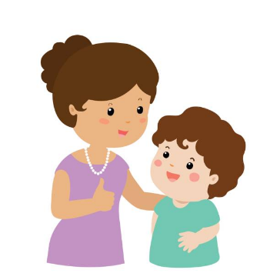
We are all so excited to welcome all the new children to school! Things are going to be a bit different this year and we may not be able to help you get your child ready for school in the ways that we normally would. Here are some things that you can do with your child to help them get ready for school:

Chat with your child about school –
What will it be like? What are they excited about? What are they worried
about? Let them know that it is ok to feel worried. Show them how positively
you feel about it.

Share books about starting school with your child. You can borrow them from the library. This can be done on the library website www.cumbria.gov. uk/libraries/services/membserv.asp
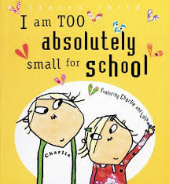
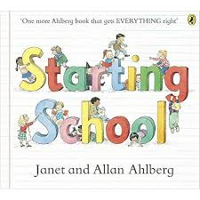
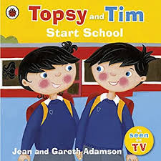
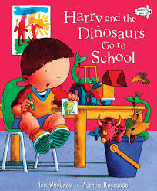
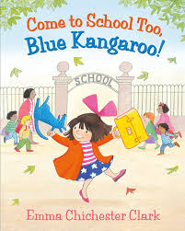

Give your child lots of praise and help them feel proud about themselves.




Have a look around our website, there will be lots of information and photos on there to talk about including photos of staff, classrooms, the outdoor areas and children taking part in activities. This will also have important information about starting school such as drop off and pick up times, PE kits, timetables and sample lunch menus

Starting school is easier for your child if they can:
- Learn their new teacher’s name, know what they look like and who they can they go to if they feel sad or worried.
- Go to the toilet on their own and wipe properly using toilet paper rather than wipes.
- Wash and dry their hands without help.
- Dress and undress themselves. Make it easy for them; have clothes with elastic waists rather than zips and buttons, Velcro fastening on shoes, teach them to put labels to the back and how to fold their clothes.
- Recognise their written name.
- Find their own bag and PE bag – customise it so they know which are theirs.
- Find their clothes and belongings, put their names on everything.
- Use a knife, fork and spoon correctly. They will have to carry their food on a tray so you could practice this too.
- Use a tissue to wipe their nose. Practice “catch it, bin it, kill it” and then encourage them to wash their hands.
- Tidy up; practice at home by making it a game. They will need to be able to hang their coat up, tidy toys and games away and help clear tables

Visit the Cumbria County council website www.cumbria.gov.uk/homelearning or the Cumbria Children and Families Information Service Facebook page for more activity ideas to share with your child at home.
For more ideas and tips visit the BBC Bitesize pages on “Starting Primary School” www.bbc.co.uk/bitesize/collections/starting-primary-school/1

