
Welcome to Newlaithes
Nursery and Infant School
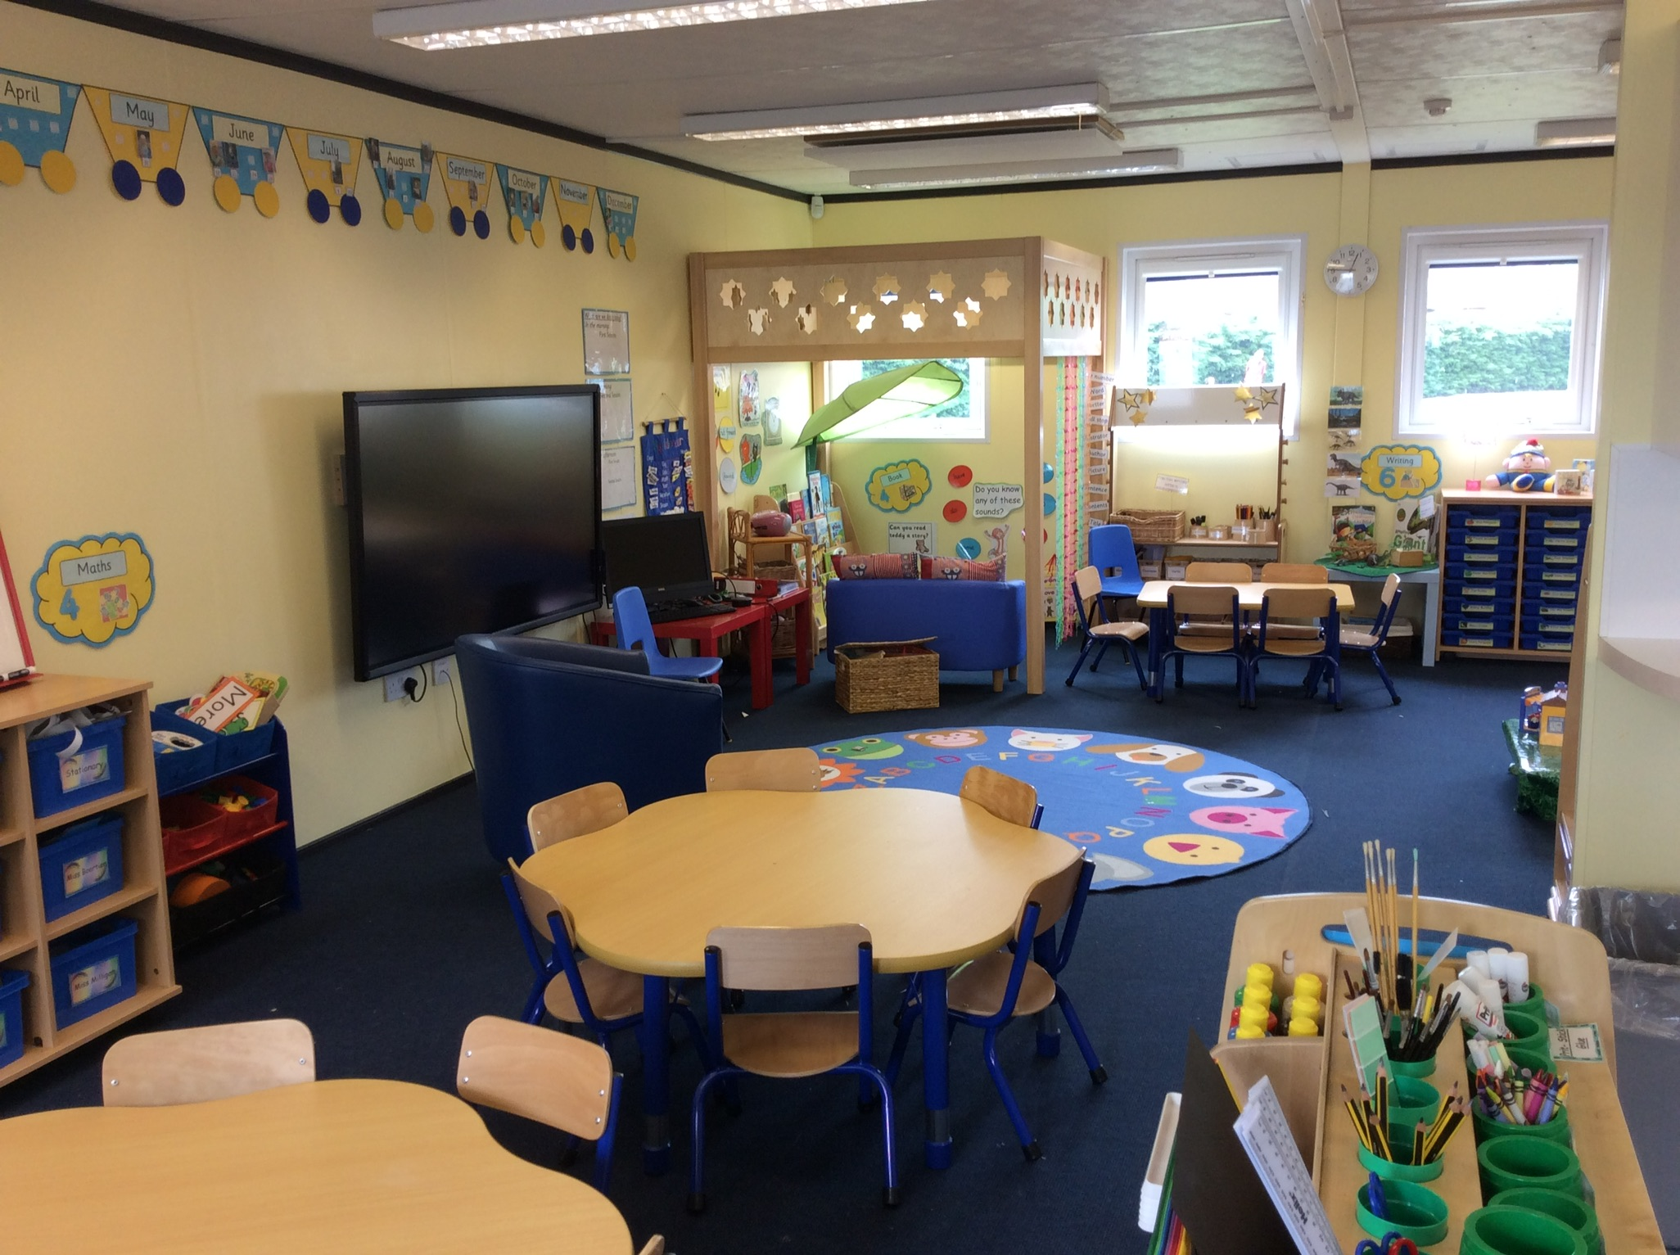

Nursery
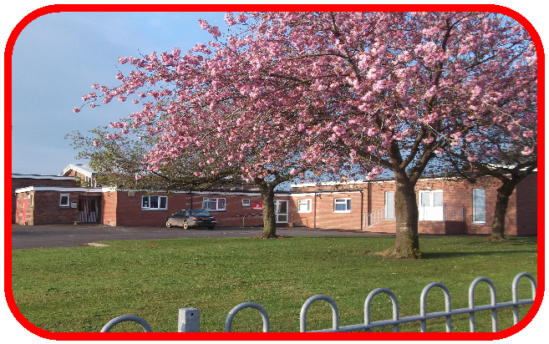
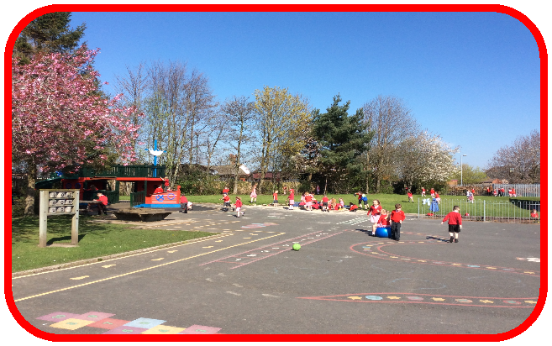

This booklet is designed to give you some general information about our school, information about the Nursery Year and hopefully answer any questions you may have. We hope you find it useful.

Our Nursery Day

Morning sessions are from 8:45am – 11:45am
Afternoon sessions are from 12:30pm – 3:30pm
Full day is 8:45am- 2:45pm.

Safety-
Morning time and home time are very busy. For your child’s safety we do not allow parents to park in our school car park and obviously not on the zig zagged lines outside the school gates. Please DO NOT park in the doctors’ surgery car park. The Royal Scot (the pub next door) have kindly said parents can park at the rear car park.

Parents and carers bringing their children in the morning or collecting at the end of the day are asked to come to the front of school at the side gate. We ask that only one family member drops/collects during these circumstances to avoid large gatherings.

What will your child need?
Uniform
White or red polo shirt (with or without logo)
Red sweatshirt, jumper or cardigan (with or without logo)
Grey trousers, shorts, skirt or pinafore
Dresses can be worn in summer (red and white)

You are free to buy uniform from any outlet. Should you wish to have the school logo on your child’s jumper/cardigan or polo shirt then these are available at the National Schoolwear Centre, Nelson Street, Denton Holme.

Footwear
Black shoes (velcro fastenings on shoes are easier to manage than laces). Please ensure these are suitable for comfort and safety. If your child comes to school in boots they will need a change of footwear as they are not suitable to wear all day.

Outdoors
We encourage our children to play and learn outside so it is very important that children bring suitable coats to nursery. We do have outdoor suits and wellies for particularly bad weather and messy play.

PE
The children in nursery will receive lots of physical play indoors and outdoors. When the children are settled into nursery we will take them into our school hall for PE. When we do this we will get the children to change into their plimsolls. So please bring black or white plimsolls (Velcro ones will be easier for your child) and socks if your child wears tights. These will stay on the children’s cloakroom peg in a named drawstring bag.

Bookbag
Please give the class teacher your child’s bookbag when they begin Nursery. Due to COVID this year we give them 5 books and 5 book reviews for 5 weeks each half term. We then ask for them to be handed back into school at the same time so we can isolate them to keep us all safe.

Jewellery is not permitted. This includes earrings.

All items of uniform and equipment must be clearly labelled with your child’s full name. Your child (and teachers!) will find this helpful.

Please do not allow your child to bring their own toys from home into nursery. We have plenty to do and it only causes upset when toys get lost, broken etc.

Toilets.
The toilets are easily accessible for the children to go at any time. Accidents do sometimes happen and these are dealt with sensitively. Your child will be given a change of clothes, which will then need to be washed and returned to school. If your child has regular accidents then please put a spare set of clothes in their drawstring plimsoll bag.

Illness.
During the Nursery Year, the children may have a number of illnesses. If your child is unwell, it is important that they stay at home and rest; only returning to school when they feel better. In line with the School Attendance Policy we are required to make first day contact with any child who is absent from school. Would parents/carers please ensure that they contact school as soon as possible on the morning of the first day of absence and let us know the reason for your child’s absence. Your child should be clear of sickness and diarrhoea for 48 hours, before returning to school.

We do have an answer phone available during the evenings, early mornings and weekends so that parent/carers are able to leave a message at any time. Telephone: 01228 525756

Medicines.

Medical-
Inhalers can be kept in school if your child has asthma. A medical permission form needs to be signed by a parent/carer to enable staff to administer this medication and the inhaler needs to be brought to school unopened in it’s original box with the instruction leaflet. Only life-saving medication will be administered at school in support of a child’s medical plan. If your child needs antibiotics please request that your doctor prescribes antibiotics which are required to be administered 3 times a day so they do not need to be administered at school. No medication will be administered without completion of the necessary paperwork by parent/carers. If your child is poorly the best place to be is at home.
Our Healthy School

Snacktime
Children in nursery have access to our snack station! Here they can choose a snack at whatever time of the day. At the beginning of term we will support them but as they become more independent and get used to the routine they will post their name, choose a drink (either water or milk) and choose their snack. There will always be a fruit bowl available but we will also include something more substantial ie toast or pancakes. Please remember to complete the information form provided so we know if your child has any intolerances or allergies. Snack costs £1 weekly. Please send the cash payment in an envelope with your child’s name written on the front weekly or monthly.

School Milk Scheme
Children can receive a 189ml carton of milk at snacktime. It comes from local farms in Cumbria and is distributed by Cool Milk Ltd. It is semi-skimmed pasteurised milk and has undergone all the necessary health and safety checks. Children under the age of 5 years are entitled to the milk free of charge. If your child would like to receive milk please register at www.coolmilk.com If you do not register your child will not receive milk in school.

School Dinners
School meals are cooked freshly at school each day. Dolce are our caterers. The children can choose from four meals each day. Please pre-order your child’s meal at home as you know best what they like! The menus are available on the school website. School meals are currently £1.50 per day and are payable by direct debit only. If you want your child to have a school dinner you will need to register with Dolce and set up a direct debit for payment on the website below.
http://www.dolce.co.uk/catering/education/direct_debit
For more information contact- customercare@dolce.co.uk or Telephone 01942707709.

Packed Lunch
Lunch boxes need to be named and are stored in the cloakroom area. We encourage healthy eating so no fizzy drinks and please avoid sweets or too much chocolate. Please try to include a piece of fruit each day.

We ask that Nursery children choose either pack lunch or school dinner for the half term. They can swap over the next term if they would like.

Lunchtime.
Lunchtime is supervised by our two nursery teaching assistants and takes place in the Nursery room. After lunch they will then have a playtime outdoors.
12:30pm- Afternoon session begins.

Starting Nursery School.
The Nursery Year is an important start to your child’s ‘school life’. We try to make the transition from home to nursery as friendly and welcoming as possible. Our Induction Programme USUALLY involves parents having an initial tour of our school, a home visit followed by a stay and play session. However due to COVID this year we ask you to send us a photograph to contact classes email address and we will drop the welcome pack at your home on a given date. Parents also get the option of part time attendance for full day children. Please visit the school website to see welcome messages from the Nursery teachers too!

Sharing information/ Assessments/ Homework/ Evidence Me.
It takes time to get to know all of our new children and families. Please talk to us if there is anything bothering your child or, if you notice a change in their behaviour. Your child’s teacher or teaching assistant will also mention any concerns or worries to you. You can speak during drop off times or if you want to talk more confidentially you can arrange a phonecall appointment with your child’s nursery teacher.

The teachers and teaching assistants will carry out informal and formal observations/assessments of your child’s skills and experiences. This information will be used to inform planning and help us to meet the needs of the children. We will keep in touch with you via our observation programme Evidence Me. Here we will send you snack menus, photographs, newsletters, information notes and weekly homework. We like to see parent postcards (photographs or notes) from you too! This ensures a two way partnership and sometimes your child may do something at home that we have never seen in school. This will continue throughout the year to build up a learning journey of your child to pass on to their Reception teacher.

There are two parent’s meetings during the nursery year. The first meeting is an opportunity to discuss how your child has settled. An End of Year Report will be sent home in the Summer.

We will send an email for you to sign up to Evidence Me (please check your junk mail!). An information sheet on how to set it up is in the welcome pack.
You can also contact us via contactclasses@newinf.cumbria.sch.uk

Our Expectations-
We will spend time with the children discussing good behaviour, friendships and how we can learn. Together we will agree some promises for how we will behave in our classroom and at school. These will be in child friendly language and kept quite simple e.g. We will be kind to each other. We promise to tidy our classroom. We will listen to others and be polite. These will apply to the children and adults!
When the children are settled through circle times and activities the children will develop the skills of making relationships, self-confidence and self- awareness and managing feelings and behaviour.
Each week a few children will be awarded a certificate. We will take their photograph and celebrate this in class.

How to help your child before starting nursery!

- Practice putting coats, jumpers and shoes on and off.
- Practice going to the toilet independently and washing and drying hands.
- Starting to look for and recognise their own name so they can find their tray, snack card etc.
- If possible, please make sure that their first day at nursery isn’t their first day of being somewhere without you.

The Foundation Stage Sta


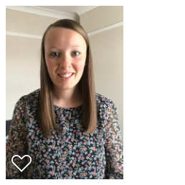
Meet the Nursery Team.
Nursery Teacher
Monday and Tuesday.
Mrs Thompson.
Nursery Teacher
Wednesday, Thursday and Friday.
Miss Boertien


Teaching Assistant
Mrs Edmondson
In nursery every morning.

Teaching Assistant
Mrs Tobin
In nursery every afternoon.

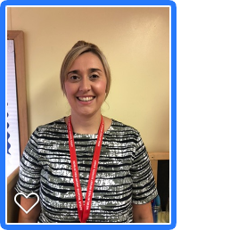
Teaching Assistant
Miss Sidney
In nursery every day.

Other adults you will meet.


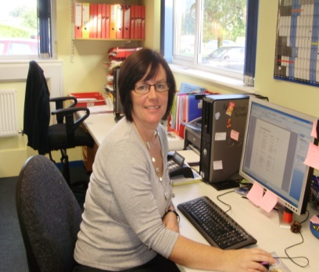
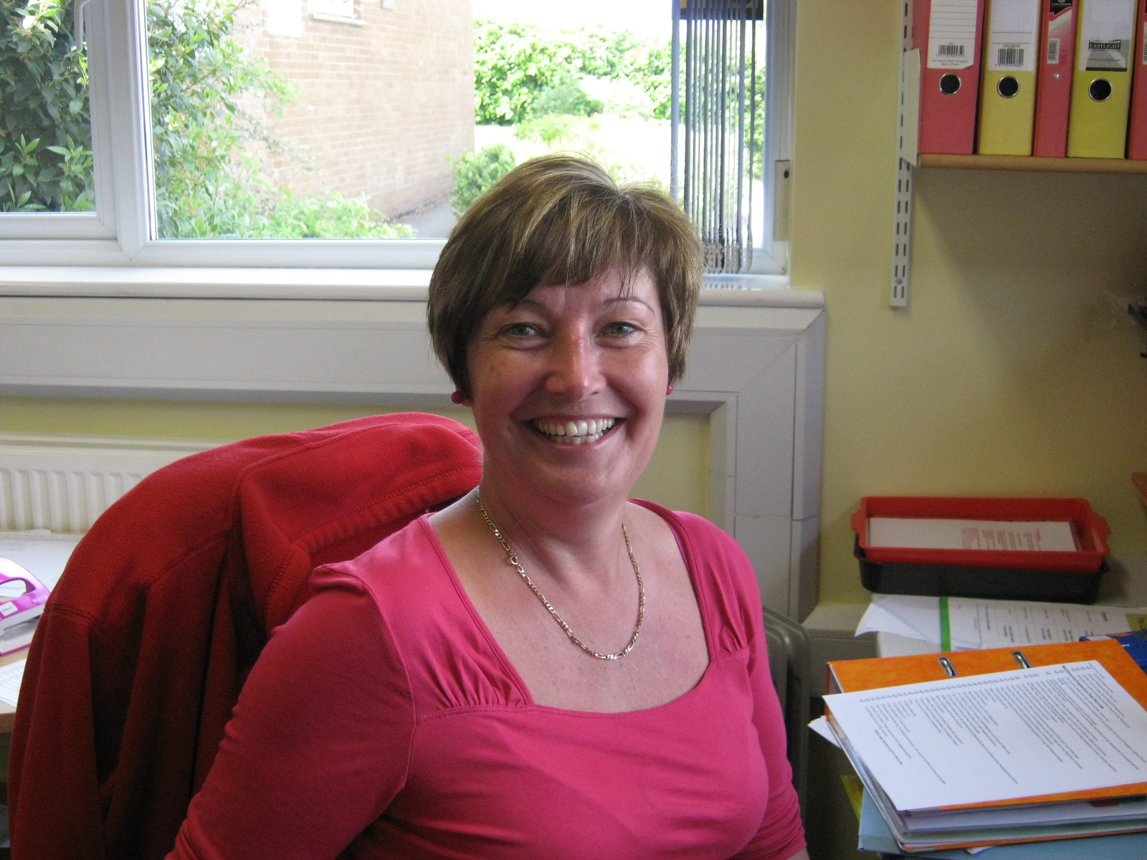
Mrs Ewbank-Higher Level Teaching Assistant

Mrs Richmond-Administration Assistant.

Mrs Nicholls–
School Business Manager.

Mrs Willows- Headteacher



Our Curriculum

It is our belief that young children learn best in an environment that provides high quality learning experiences and promotes independence. The classrooms (inside and outside) are organised into areas that promote learning through play and provide well planned opportunities to develop skills and explore new experiences. These are an integral part of your child’s development and help to provide a well-balanced curriculum.

During the first term the children will have a lot of adult support in these areas of the classroom. Teachers will model and support play, demonstrate how to use equipment and how to tidy up!

Teachers and teaching assistants can then spend quality teaching time with small groups of children whist other groups plan in the areas.

The Early Years Foundation Stage of education is for children from birth to five years old. It is divided into seven learning areas.
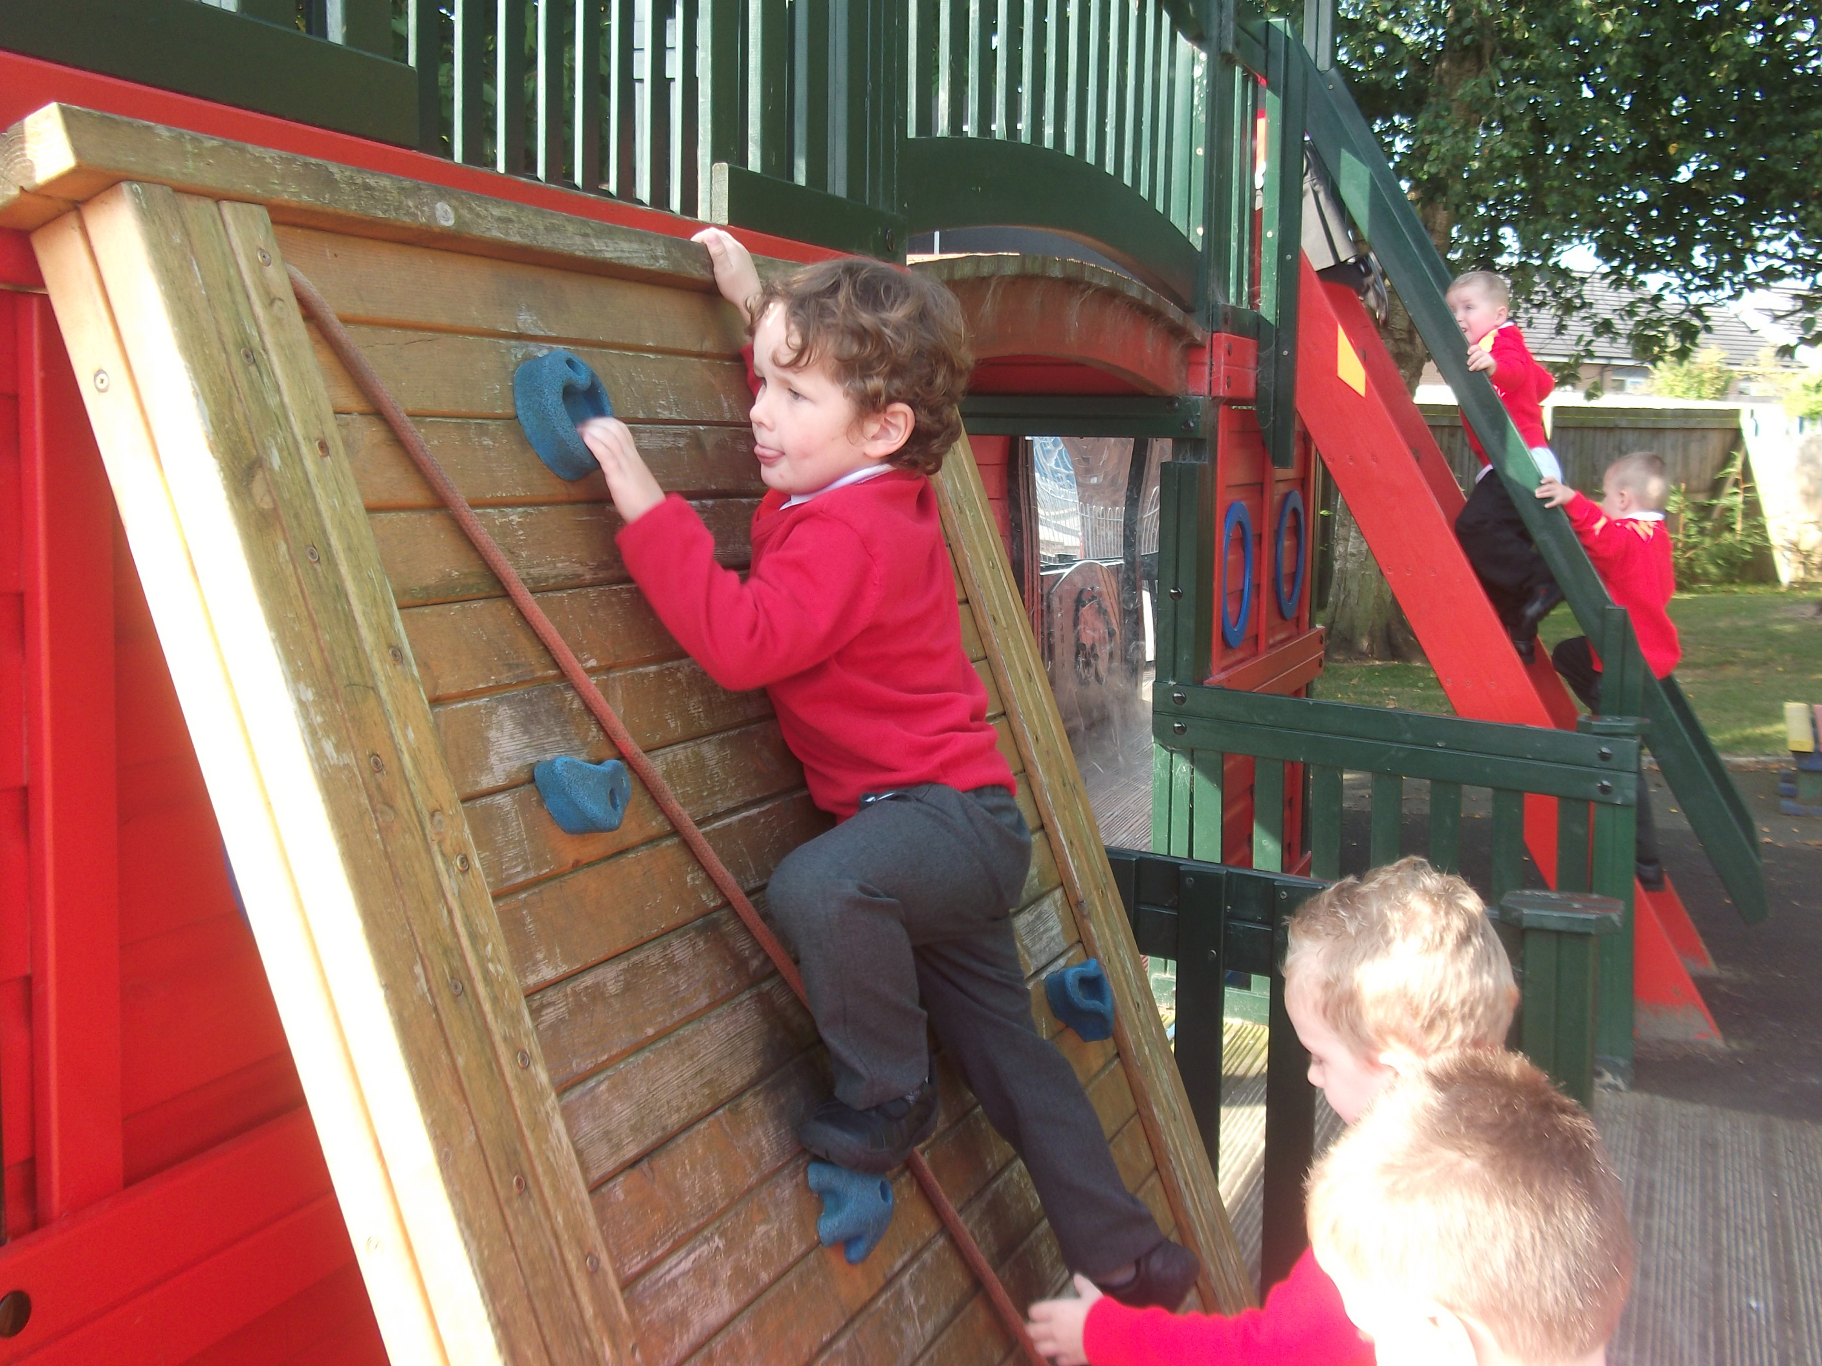
The early years are vital in children’s development. Children develop rapidly during this time – physically, intellectually, emotionally and socially. The EYFS is about developing key learning skills such as listening, speaking, concentration, persistence and learning to work together and co-operate with other children. It is also about developing early communication, literacy and numeracy skills that will prepare young children for Key Stage 1 of the National Curriculum.

Play is an important part of the EYFS. Well-planned play, both indoors and outdoors, is a key way in which young children learn with enjoyment and challenge. Through play, in a secure environment with effective adult support, children can –
- explore, develop and represent learning experiences that help them make sense of the world
- practice and build up ideas, concepts and skills
- learn how to control impulses and understand the need for rules
- be alone, be alongside others or co-operate as they talk or rehearse their feelings
- take risk and make mistakes
- communicate with others as they investigate or solve problems
- express fears or relive anxious experiences in controlled and safe situations

We hope your child will be happy at
Newlaithes Nursery and Infant School and we look forward to


welcoming you.
Visit our school website for more information www.newinf.cumbria.sch.uk

