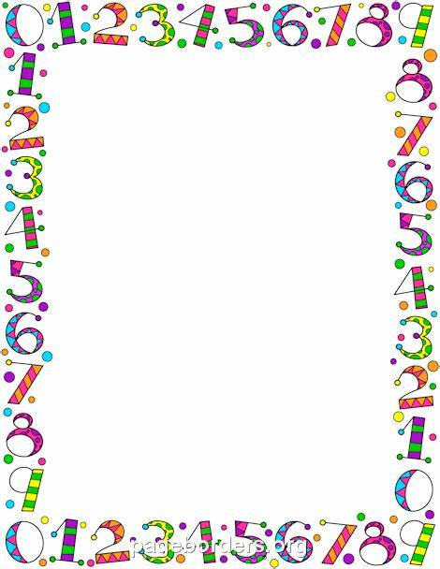
Number Maths Ideas.
Choose some objects- Lego, beads, pasta and fill a shoe with the objects but can you predict how many objects it will take to fill? Carefully count them in and out of the shoe. Can you find a different object to fill- a spoon, cup, bucket...
Take turns to count to 20 with a grown up, can you speed up, can you whisper or shout the numbers?
Practice counting in 2’s. Use 2 pence coins, throwing them in a bowl each time you say a number, or try using a pair of socks.
Roll a dice, whatever number you land on can you do that many jumps, hops, steps, bunny hops etc..
Write numbers on post it notes or scrap piece of papers either from 1-5, 1-10 or 1-20. Ask your child to order these numbers. Turn you child away from the numbers or blind fold them. Then…
Take a number away,
Swap some numbers around,
Turn the numbers upside down,
Encourage your child to count from zero if they are unsure of the changes in the order?
Write numbers from 0-9, 10-20 on a piece of paper. Put that piece of paper in front of your child, then finger trace a number on your child back. Can they guess what number it is? Can they have a go at writing it on a piece of paper or a tray with sand in?
Fix 10 pegs to a coat hanger, ask you child to slide 2 across, 5 across etc.. can they take one away, can they add a peg?
Adding with dominoes- look at the dots on each side of the dominoes. Can you add both sides together? How many is there? Can you write that as a number sentence?

