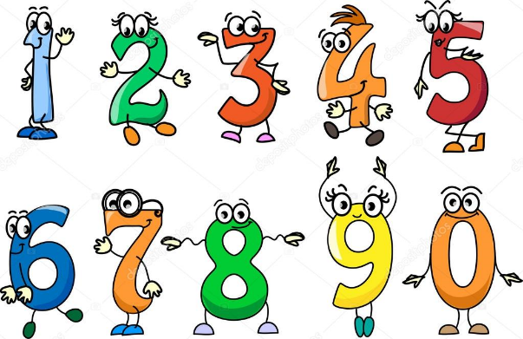
Practical Maths Ideas…
Can you get me 1 car? Progress to 2, 3, 4…
Can you get me 6 objects? Then progress to 10 objects.
Could be toys, plates, stones…
Children need to get the objects and place them in a line and count them accurately.

Addition and subtraction with up to 10 different objects.
For example…3 cars now add 4…how many altogether?
10 books now take-away 6…how many altogether?
Progress to recording it- 3 + 4= 7, 10 – 6=4.

Recognise numerals 0-5 then 6-10.
Flash card activities-
Hide them around the house/ garden and your child has to find them.
Stick them on the fridge/ in their bedroom and reinforce them during everyday routines.
Show your child a number and they have to do the same amount of actions ie claps, jumps, stamps…
Can they match the correct amount of toys/ objects to them?
Can they recognise them when you point to them?
Can they order them from 0-5?
Can they copy write them?

Representing number.
Show your child 5 fingers or roll a dice…
Can they record this using 5 dots, 5 lines, 5 faces etc?

Writing numerals 0-10.
Practise writing numerals … make posters, paint them, do collages, make them with natural objects…

