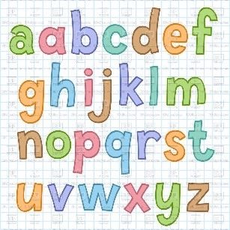
Literacy Ideas…
Reading.
Share lots of stories and talk about them. See ‘ten top tips for reading stories to your child’.
Can your child retell the story?

Can your child point to the text from left to right, top to bottom?
Can your child read familiar words such as their name, mum, dad…siblings
names?

Writing.
Use this book to encourage your child to draw pictures. Make sure they hold their pencil correctly- see image. They might want to draw/write about a story that they have listened to or their daily news (something they have done that day).
Also let them practise writing their first and then second name.
We encourage the children to emergent write which means they have a go at doing their own writing …. See developmental stages of writing sheet. We hope that children leave nursery writing recognisable letter shapes or sounding words out.
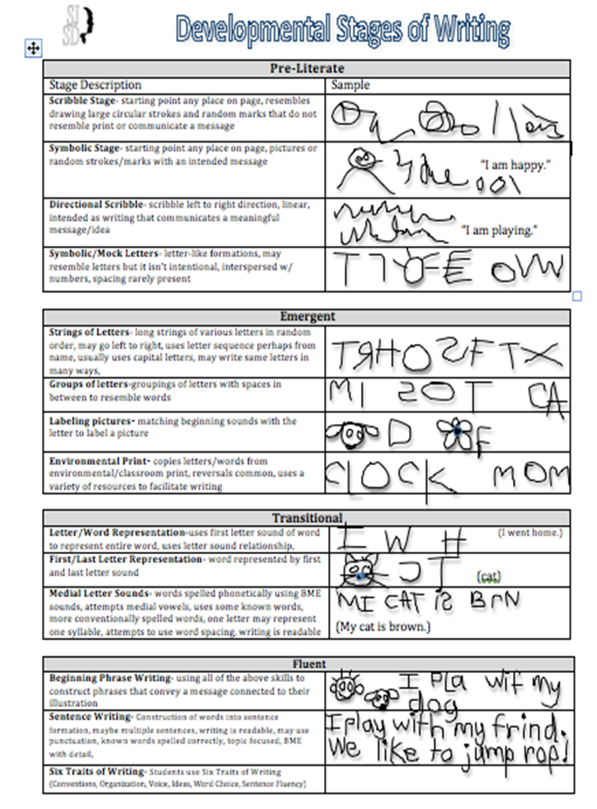

Phonics.
Practise singing nursery rhymes- can your child sing 5 from memory?
To say initial sounds in words- what does book begin with?
To orally blend three letter words. For example we say c-a-t in a robot voice and they say cat.

Please practise these sounds with your child. We have taught up to letter y. See sheet.
Example/ explanation:
These are the letter sounds- not the capital as in ABC but the sounds.
Questions such as ‘What sound does apple begin with?’

Example Activities:
Hide individual letters around the house/ garden for your child to find and name.
Play ‘I spy with my little eye, something beginning with…’
Write some of the letters in large writing on big pieces of paper- stick them on the fridge, bedroom doors…
Practise writing the letters.
Find objects beginning with the letters.
Practise drawing pictures beginning with the letters.
Find and cut the letters from newspapers and magazines.
Make two sets of the letter sound cards and play snap and matching games.
Find the letters within a box of magnetic letters.
Find the letters within stories.

