Got lots of recycling? Why not use it to create some marvellous things!

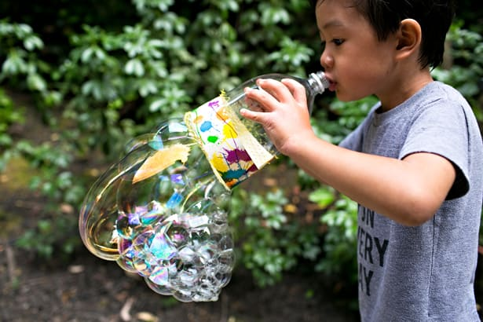
First up is the bubble blower using a plastic bottle, all you need to do is cut the bottom end of the bottle off then let your child decorate it!
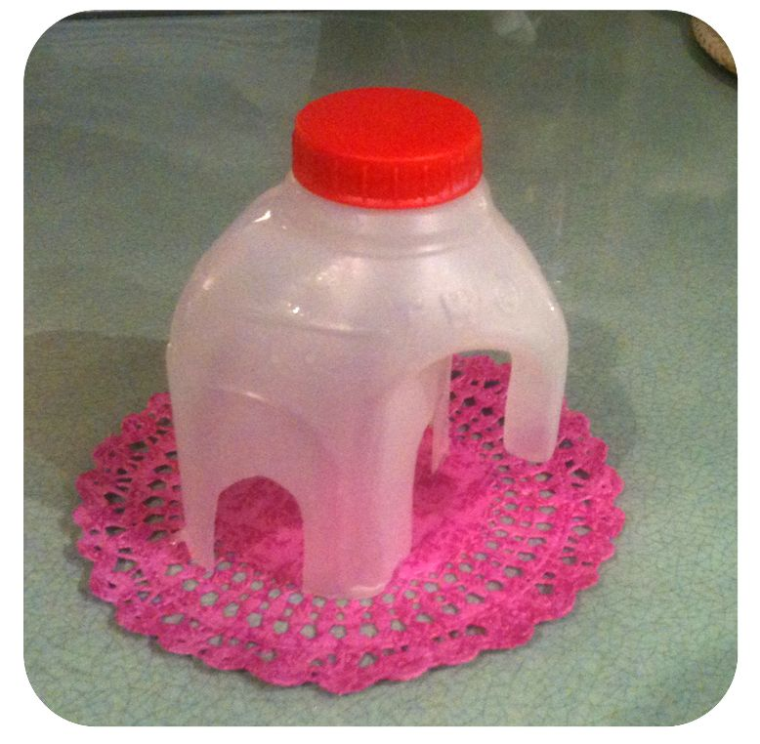
For the bubble mixture its just washing up liquid and water mixed together…simple but fun!

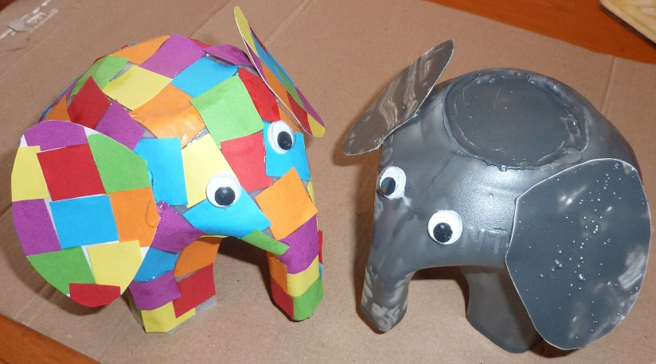
Next is a plastic milk bottle elephant, I have made one of these myself and I love it!
All you do is cut the top of your milk bottle off, then your child can choose how to decorate it!
When I made mine I used decopage and pva glue, you can do this with tissue paper just the same!

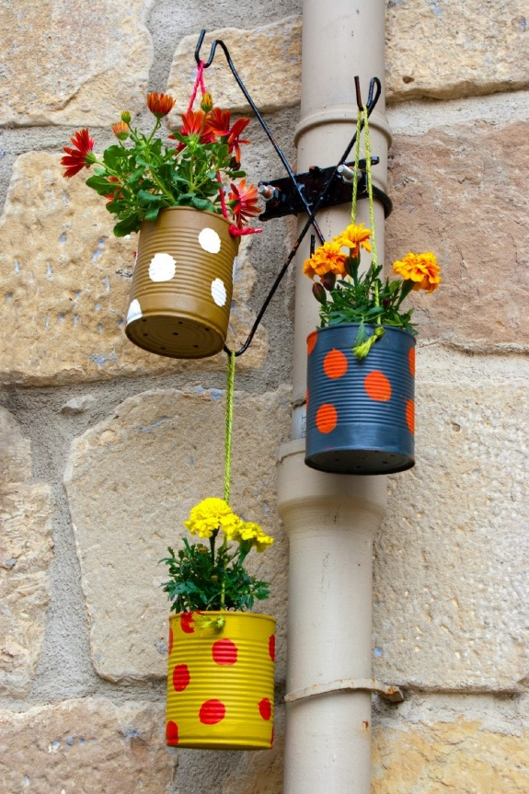
These are also really simple but effective!
Just use a tin and let the child decorate it. Make sure you masking tape the top rim where its sharp whilst they are decorating to avoid any injuries!
Once they’re dry put some soil in and plant some seeds and watch your beautiful flowers grow! But don’t forget to water them!
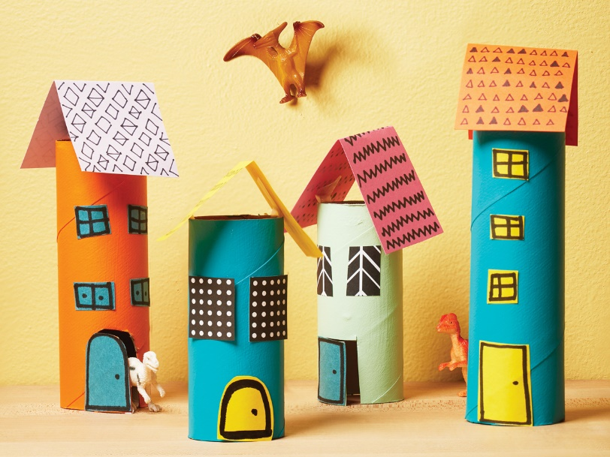
Tip: If you have a drill, drill a hole in the bottom of the tin so the water doesn’t pile up inside.

Finally some toilet tube houses! All you need to do is paint and decorate them as you please! You could make a fairy village out of them, or a castle. You could also make little houses for your toy animals or happy land people!

Love Miss Codona

